**Project Description:**

Farely is a mobile fare-tracking application developed to help students and workers manage their daily transportation expenses. Created by Team Rowlet, the app aims to address the common challenge of tracking fares manually or relying on memory, which often leads to poor budgeting. Farely simplifies fare monitoring by offering users tools to record commutes, set weekly or monthly budgets, and review summarized expenses.

**Requirements Summary:**

|  |  |  |
| --- | --- | --- |
| **MINIMUM REQUIREMENTS** | ANDROID | |
| Processor Cores | Dual Core |
| OS | Android 8.0 (Oreo) or higher |
| RAM | 2 GB |
| IOS | |
| Device | iPhone 6s or newer |
| OS | iOS 12 |
| RAM | 2 GB |
|  | ANDROID | |
| **RECOMMENDED**  **REQUIREMENTS** | Processor Cores | Octa Core |
| OS | Android 11 (R) or higher |
| RAM | 4 GB or more |
| IOS | |
| Device | iPhone 8 or newer |
| OS | iOS 14 or higher |
| RAM | 3 GB or higher |
| **OTHER REQUIREMENTS** | Internet | Wi-Fi or Mobile Data |

Table 1. System Requirements

Designed to be lightweight and accessible across a wide range of devices, including both Android and iOS platforms. Farely works on both Android and iOS platforms, supporting devices running Android 8.0 (Oreo) and above, or iOS 14 and above. These baselines ensure compatibility with current APIs, user interface components, and data security protocols.

**Overview**

With some members balancing work and multiple academic responsibilities, in-person testing wasn’t feasible. As an alternative, the evaluation will be conducted remotely using platforms such as Discord, allowing the developers to observe participants in real time as they interact with the prototype.

With that said, the Evaluation plan is split into two separate parts: Usability Specifications, Heuristics Evaluation.

|  |  |
| --- | --- |
| **Technique** | **Description** |
| Usability Specifications | Usability Specifications were used to evaluate how easy and effective Farely’s prototype is to use. Participants were given specific tasks to perform while the team observed how smoothly they completed them and how long each task took. Tasks focused on key features of the app, such as navigating the home screen, logging commutes, setting budgets, and viewing summaries. These tasks helped the team identify areas where users struggled and allowed us to assess how user-friendly the prototype really is. |
| Heuristics Evaluation | Heuristics Evaluation will evaluate the UX design of the Prototype in an industrial-standard usability principle. This technique is chosen to provide a quick and approachable way to assess the validity of the Prototype’s Design when time or resources are less. |

The tasks for this Prototype are split into three (3) different Sections: Main Menu Tasks, Input fare Tasks, and Budget/Summary Tasks. Below are some of the tasks that the selected participants will be asked to perform for each Section to showcase the Prototype’s functionality:

Main Menu Tasks

* Launch and exit the prototype
* Navigate between pages (e.g., Input Fare, Set Budget, Summary)

Input Fare Tasks

* Enter new fare entries
* Edit or delete a specific entry

Budget & Summary Tasks

* Set or adjust weekly/monthly budgets
* View total spending and remaining budget

Reasons that these tasks were selected for the participants since the Prototype was designed with these measures in mind:

* Easy Navigation
* Allow users to do CRUD (Create Read Update Delete)

**Data Analysis**

# Usability Specifications

During online testing, Team ROWLET observed that most participants interacted well with the prototype. Nearly all of them were able to complete the assigned tasks with little to no difficulty. They quickly learned and remembered how to navigate the app. However, some participants needed more time to fully understand the overall flow before getting comfortable. Additionally, a few buttons were unresponsive when clicked, likely due to missed constraint settings during the prototype design.

|  |  |  |  |
| --- | --- | --- | --- |
| Task | Mean | Interpretation | Classification |
| Main Menu Task | 0.40 seconds | Highly Acceptable | Successful |
| Input Fare Task | 4 minutes | Highly Acceptable | Successful |
| Budget & Summary  Task | 4 minutes and 40 seconds | Highly Acceptable | Successful |

Table 3. Task Time

Table 3 shows the results of the timed tasks during Online Testing. The data shows that the Participants were overall able to accomplish each task sections with promising completion time. With this result, the prototype is interpreted as successful in all three (3) task sections.

# Heuristic Evaluation

Evaluation of Farely will also use the 10 Usability Heuristic method of Evaluation.

*Visibility of System Status*

The Prototype will keep the participants informed on what is happening in the Prototype.

## Match Between System and Real World

The prototype speaks the user’s language, with familiar words, phrases, and concepts rather than system-oriented terms.

*User control and Freedom*

The Prototype offers to deal possible mistakes through confirmation modals for every action.

*Consistency and Standards*

Users will not have to worry whether different words, situations, or actions mean the same thing.

## Error Prevention

Error Messages are Carefully designed which prevents a problem from occurring in the first place.

## Recognition rather than recall

Make objects, actions, and options visible. The user does not have to remember information from one part of the dialogue to another.

## Flexibility and Efficiency of Use

The prototype caters to both experienced and inexperienced users. Users readily tailor frequent actions

## Aesthetic and Minimalist Design

The prototype does not contain information which is irrelevant or rarely needed. Every extra unit of information in a dialogue competes with the relevant units of information and diminishes their relative visibility.

## Help Users Recognize, Diagnose, and Recover from Errors

Error messages are explained in plain language (no codes), precisely indicate the problem, and constructively suggest a solution.

## Help and Documentation

User can easily find help and documentation when need to interact with the prototype. This information is easy to search for.

## Heuristics Conclusion

Overall, the Prototype was able to follow most of the Evaluations with some issues that still need to be properly addressed or fixed.

**Feedback**

While most of the feedback was overwhelmingly positive, some participants raised concerns about the overall visual impact and layout of the prototype.

**Does the prototype need to be altered based on the feedback?**

The prototype was generally successful and met many of its usability goals. However, based on participant observations, the team made improvements to enhance clarity and user navigation.

**What improvements were made to the design?**

One key change involved reworking the visual layout, particularly on the home page, to ensure that important features are properly emphasized. Some participants initially had difficulty understanding the overall flow of the prototype, so adjustments were made to make the interface more user-friendly. These revisions aimed to reduce confusion and ensure that the most relevant content stands out, improving both the first-time user experience and the app’s overall usability.

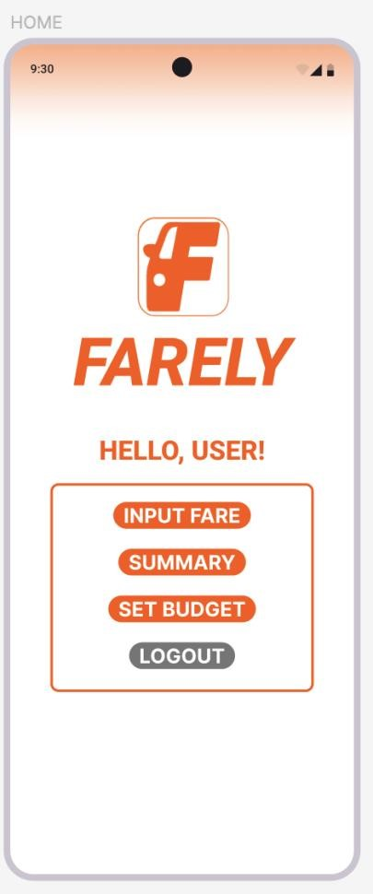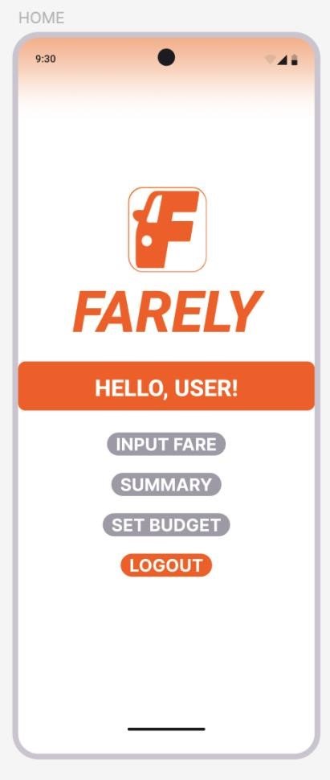

**Before Alterations** **After Alterations**

**Critique and Summary:**

**What were the advantages and disadvantages of your evaluation?**

One major advantage of our evaluation was the ability to collect data and feedback through online testing. It was convenient to reach out to participants via social media platforms and send them links to access the prototype. Conducting the test over Discord allowed for easy communication and screen sharing.

However, since all evaluations were conducted remotely, we weren’t able to observe participants' actual reactions in real-time or face-to-face. This limited our understanding of their physical interactions with the prototype. Inconsistent internet speeds sometimes delayed the testing process or affected how smoothly the prototype was viewed and evaluated.

**What would you have done differently, knowing what you know now?**

If given more time, we would have conducted two rounds of evaluation: one for the initial prototype and another after revisions. This would have provided more detailed insights into improvements and usability over time. With better resources, we would have also considered building a functional back-end to turn the prototype into a fully working application ready for deployment.

Summary of the Project

Farely’s prototype was created to help users track their daily transportation expenses in a simple and organized way. During testing, users were able to complete the tasks easily, and they liked the clean design and smooth navigation. Features like fare logging, budget setting, and summary viewing worked well and were helpful.

Some users needed a bit of time to understand the flow of the app, and we weren’t able to add online features or real-time updates because of time and resource limits. We also did all our testing online through Discord, so we couldn’t fully observe user reactions in real time.

If we had more time, we would’ve added more features like notifications, better visuals, and a working budget comparison. Overall, the project was a success. The prototype was easy to use, served its purpose, and gave us a better understanding of how to design with users in mind.